Case Study Report



**Tech Saksham**

Data Analytics with Power BI

**360-Degree Business Analysis of Zomato Delivery App using Power BI**

**Government Arts & Science College – Dharmapuri**

|  |  |
| --- | --- |
| **NAAN MUDHALVAN ID** | **NAME** |
| 322497769E7CA4FB11B4ED1BBC31F21C | SANTHIYA M |

**TRAINER NAME:** R UMAMAHESWARI

**MASTER NAME:** R UMAMAHESWARI

**ABSTRACT**

In the fiercely competitive landscape of today's digital realm, the food delivery industry is undergoing a seismic shift, with platforms like Zomato grappling to maintain their edge through savvy data-driven strategies. The "360-degree Business Analysis of Zomato Delivery App using Power BI" project emerges as a beacon of insight, aiming to arm Zomato with a formidable arsenal of comprehensive data analysis and visualization capabilities. By meticulously dissecting pivotal metrics such as order volumes, delivery hotspots, preferred cuisines, and customer feedback, the project endeavors to unearth actionable insights crucial for optimizing operational efficiency and enriching customer experiences. Through the sophisticated synthesis of data analytics and visualization methodologies, this initiative seeks to empower Zomato's decision-making processes, fostering a culture of innovation and customer-centricity that is indispensable in the fiercely competitive arena of online food delivery services. The outcomes of this endeavor hold the potential to redefine Zomato's business strategies, fortifying its position and propelling it towards sustained success in the ever-evolving digital ecosystem.

**INDEX**

|  |  |  |
| --- | --- | --- |
| **S. No.** | **Table of Contents** | **Page No.** |
| 1 | Chapter 1: Introduction | 04 |
| 2 | Chapter 2: Services and Tools Required | 07 |
| 3 | Chapter 3: Project Architecture | 09 |
| 4 | Chapter 4: Modeling and Result | 11 |
| 5 | Conclusion | 22 |
| 6 | Future Scope | 23 |
| 7 | References | 24 |
| 8 | Links | 24 |

**CHAPTER 1**

**INTRODUCTION**

In the rapidly evolving landscape of online food delivery, extracting actionable insights from data is paramount for companies like Zomato to refine operations and elevate customer satisfaction. Utilizing sophisticated analytics tools like Power BI provides a strategic edge, facilitating efficient extraction of valuable insights from vast datasets. With competition escalating in the online food delivery sector, Zomato acknowledges the significance of embracing a comprehensive approach to business analysis. This proactive stance ensures staying ahead and meeting the ever-changing needs of customers.

**1.1 Problem Statement:**

Amidst the cutthroat competition in the online food delivery sector, Zomato grapples with the daunting task of effectively parsing through vast data troves to glean comprehensive insights into its operational dynamics. Conventional data analysis methods often prove inadequate in furnishing a holistic perspective on pivotal metrics like order volumes, customer inclinations, and market dynamics. This shortfall impedes Zomato's capacity to pinpoint lucrative growth avenues, fine-tune service provisions, and bolster overall operational efficacy. Furthermore, the absence of real-time analysis capabilities compounds the challenge, resulting in delayed decision-making and missed opportunities for strategic interventions.

**1.2 Proposed Solution:**

For Zomato, embracing advanced analytics solutions like Power BI can offer a powerful solution to these challenges. Power BI provides robust data visualization and analysis capabilities, allowing Zomato to gain deeper insights from its vast datasets. With Power BI, Zomato can create interactive dashboards and reports that offer a comprehensive view of key metrics such as order volumes, customer preferences, and market trends in real-time. This enables quicker and more informed decision-making, helping Zomato to identify growth opportunities, optimize service offerings, and enhance overall business performance. By leveraging Power BI, Zomato can stay ahead of the competition and continue to thrive in the dynamic online food delivery market.Top of Form

**1.3 Feature**

**1. Real-Time Analysis:**

The dashboard offers real-time analysis of Zomato's delivery app data, allowing users to monitor key metrics and trends as they occur. This capability facilitates timely decision-making by providing up-to-date information on factors like order volumes, delivery times, and customer feedback.

**2. Customer Segmentation:**

Users can segment Zomato customers based on various criteria such as location, order frequency, cuisine preferences, and spending habits. This segmentation enables targeted marketing strategies and personalized recommendations, as Zomato can tailor its promotions and offerings to specific customer segments.

**3. Trend Analysis:**

The dashboard identifies and visualizes trends in customer behavior, restaurant popularity, and delivery patterns. By analyzing these trends, Zomato gains insights into evolving market dynamics and consumer preferences. This information is invaluable for adjusting business strategies, launching new features, and staying ahead of competitors.

**4. Predictive Analysis:**

Leveraging historical data and predictive analytics techniques, the dashboard forecasts future trends in customer demand, restaurant performance, and market opportunities. This predictive capability allows Zomato to engage in proactive planning and strategy development, anticipating changes in the market and positioning itself for sustained growth and success.

* 1. **Advantages**

The Power BI dashboard provides Zomato stakeholders with a comprehensive overview of delivery app data, facilitating informed decision-making through real-time analysis, predictive analytics, and trend identification. This holistic approach optimizes operational efficiency and resource allocation, bolstering Zomato's competitive edge in the online food delivery market. Customer segmentation enables targeted marketing campaigns, enhancing engagement and loyalty while maximizing return on investment. By leveraging trend analysis and predictive analytics, Zomato engages in proactive strategic planning and business expansion, staying ahead of industry trends and consumer preferences.

The utilization of advanced analytics tools like Power BI ensures superior services for customers and partners alike. Moreover, the dashboard's capability to identify inefficiencies, streamline processes, and optimize resource utilization leads to enhanced operational performance and significant cost savings. This integrated approach empowers Zomato to navigate the dynamic landscape of the food delivery industry with agility and innovation, positioning itself as a leader in the market while continually evolving to meet the evolving needs and expectations of its users.

* 1. **Scope**

The project aims to develop a customized Power BI dashboard for thorough analysis of Zomato's delivery app data. This involves amalgamating data from various sources such as transaction records, customer feedback, and market demographics to provide a holistic view of Zomato's business operations. Through interactive features like dropdown menus and filters, users can dynamically explore and analyze data, gaining deeper insights into crucial metrics and trends.

Furthermore, the project extends beyond data visualization to encompass predictive and prescriptive analytics. Leveraging historical data and advanced analytical techniques, the dashboard will facilitate predictive modeling to forecast future trends in customer demand, restaurant performance, and market opportunities. Additionally, prescriptive analytics will offer actionable recommendations to optimize operational processes, marketing strategies, and overall business performance.

Ultimately, the project aims to empower Zomato stakeholders with timely and relevant insights to drive strategic decision-making, enhance operational efficiency, and maintain competitiveness in the online food delivery market. By providing a comprehensive platform for data analysis and decision support, the project seeks to support Zomato's growth and success in catering to the evolving needs of customers and partners.

**CHAPTER 2**

**SERVICES AND TOOLS REQUIRED**

**2.1 Services Used**

* **Data Collection and Storage Services:**

Azure Data Factory or AWS Glue: Utilized for orchestrating and automating the collection, ingestion, and transformation of data from various sources such as transaction records, customer feedback, and market demographics.

Azure Blob Storage or AWS S3: Employed for storing the integrated data securely and cost-effectively, providing scalable and reliable storage solutions.

* **Data Processing Services:**

Azure Stream Analytics or AWS Kinesis Data Analytics: Utilized for processing and analyzing real-time streaming data from Zomato's delivery app, enabling quick insights extraction and decision-making based on the latest information.

* **Machine Learning Services:**

Azure Machine Learning or AWS SageMaker: Leveraged for building predictive models based on historical data from Zomato's delivery app, enabling forecasting and predictive analytics to anticipate future trends in customer demand, restaurant performance, and market opportunities.

By leveraging these services, the project aims to establish a robust data infrastructure and analytical framework that supports real-time analysis, predictive modeling, and actionable insights generation for Zomato stakeholders. This enables informed decision-making, strategic planning, and business growth in the competitive online food delivery market.

**2.2 Tools and Software Used:**

* **Tools:**
* **Power BI:** The primary tool for this project is Power BI, which will be utilized to develop interactive dashboards for real-time visualization of Zomato's delivery app data.
* **Power Query:** This tool serves as a data connection technology, allowing users to discover, connect, combine, and refine data from various sources such as transaction records, customer feedback, and market demographics.
* **Software Requirements:**
* **Power BI Desktop:** This Windows application is essential for creating reports and designing interactive dashboards that will be published to Power BI.
* **Power BI Service:** This online Software as a Service (SaaS) platform is used for publishing reports, creating new dashboards, and sharing insights with stakeholders within Zomato.
* **Power BI Mobile:** The mobile application enables users to access reports and dashboards on the go, providing flexibility and accessibility for stakeholders to stay updated with real-time insights from Zomato's delivery app data.

**CHAPTER 3**

**PROJECT ARCHITECTURE**

**3.1 Architecture**

* **Data Collection:**
* Utilize web scraping techniques or access Zomato's API to collect comprehensive data on restaurants, customer reviews, ratings, and other relevant information.
* Gather demographic data from open data platforms or government databases to enrich the analysis.
* **Data Storage:**
* Store collected data securely in a cloud-based storage solution such as Azure Blob Storage or AWS S3.
* Organize data into structured formats conducive to analysis, ensuring efficient data retrieval and management.
* **Data Processing:**
* Preprocess and clean the collected data using tools like Python or Azure Databricks to ensure data quality and consistency.
* Perform data transformations, filtering, and aggregation to prepare the data for analysis.
* **Machine Learning:**
* Implement machine learning algorithms to analyze Zomato's delivery app data and derive predictive insights.
* Train models to forecast customer preferences, restaurant performance, and market trends, aiding in strategic decision-making.
* **Data Visualization:**
* Utilize Power BI for data visualization, creating interactive dashboards and reports to present insights derived from the analyzed data.
* Incorporate a variety of visualization techniques such as charts, graphs, maps, and tables to effectively communicate findings to stakeholders.
* **Data Access:**
* Publish developed dashboards and reports to Power BI Service, allowing stakeholders to access and interact with them online.
* Enable data access and exploration through Power BI Mobile, ensuring accessibility across various devices for on-the-go decision-making.

**CHAPTER 4**

**MODELING AND RESULT**

* 1. **Modeling :**

**Query Editor**

Begin by clicking on "Transform Data" to open the Power Query Editor.

In the Power Query Editor, navigate to "Append Queries" and select "Append Queries as New."

Choose two or more tables from the available options, focusing only on Zomato countries' data.

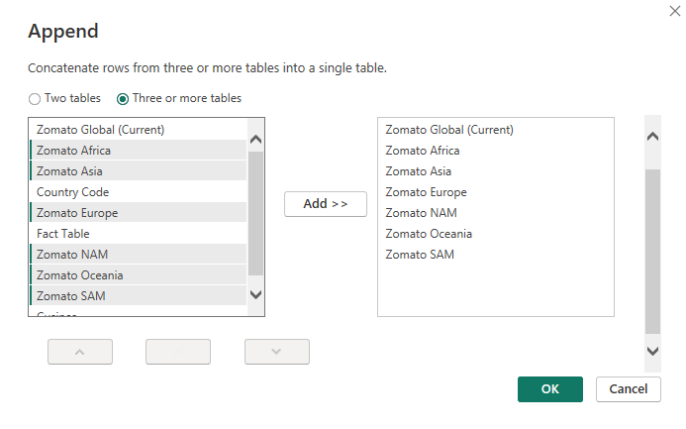

Append the selected tables and rename the resulting table as "Zomato Global.

**Split Columns:**

Next, split the "Restaurant Name" and "Address" columns into two separate columns.

Select the column, click on "Split Column," choose "By Delimiter," and enter a comma as the delimiter

Split at the left-most delimiter occurrence and click "OK" to create two new columns (Restaurant Name, Address.1 , Restaurant Name, Address.2).

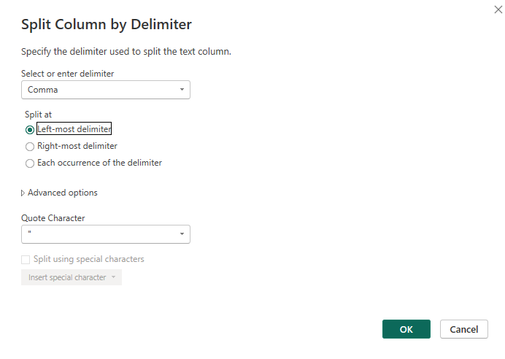

Rename the columns as "Restaurant Name" and "Restaurant Address."

**Create Cuisines Table:**

Duplicate the "Zomato Global" table and rename it as "Cuisines."

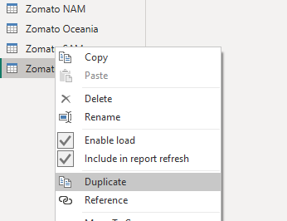 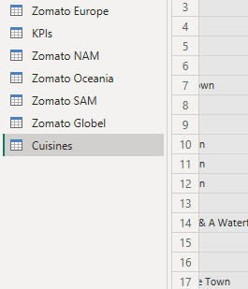

Remove all columns except "Restaurant ID" and "Cuisines."

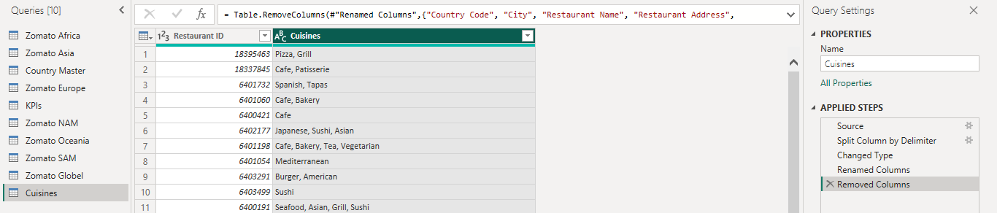

**Split Cuisines Column:**

Select the "Cuisines" column, click on "Split Column," choose "By Delimiter," and select each occurrence of the delimiter.

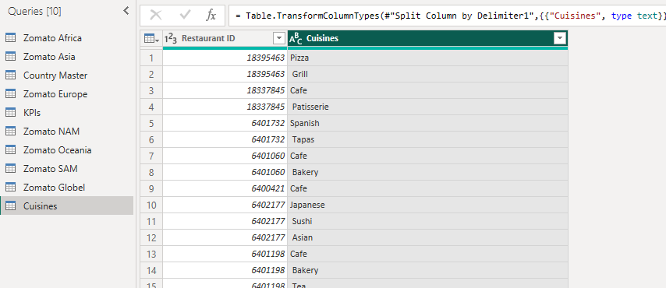

In advanced options, split into rows and click "OK."

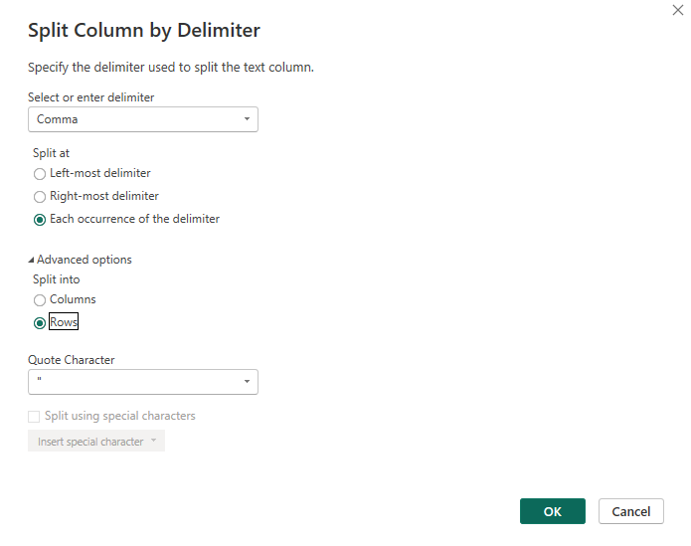

**Prepare Country Master Data:**

Select the "Country Master" from the queries list and rename the column as "Country Code."

Remove any blank rows in the column by selecting "Remove Rows" and choosing "Remove Blank Rows."

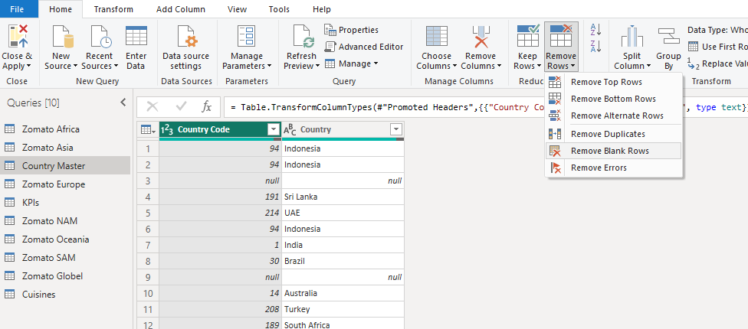

**Prepare KPI's Data:**

Select the "KPI's" table from the queries list and rename it as "Fact Table."

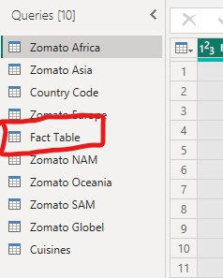

**Disable Load for Country Names:**

Since the Zomato Global data already includes all countries, disable the load for the "Country" table.

Right-click on the table, uncheck "Enable Load," and click "Continue" to apply the changes. The country names will appear in italic font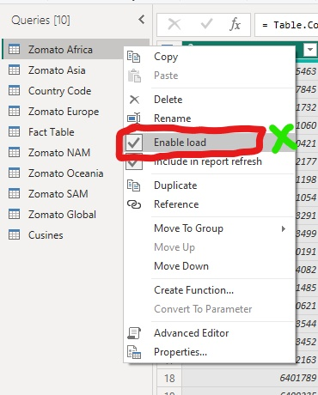 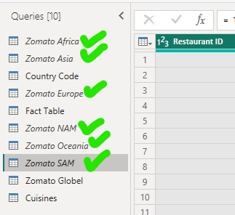

* **Close and Apply:**

Finally, click on "Close and Apply" to save the changes and apply them to your Power BI model.

**4.2 Model View:**

**Here's the content written in a properly formatted manner:**

**Table Display:**

* In the model view, you will see four tables: "Country Code," "Zomato Global," "Fact Table," and "Cuisines."

**Establishing Relationships:**

* Establish relationships between the tables to enable seamless data integration.
* Link the "Country Code" table to the "Zomato Global" table by arranging the "Country Code" column in both tables.
* Link the "Zomato Global" table to the "Fact Table" by arranging the "Restaurant ID" column in both tables.
* Link the "Cuisines" table to the "Zomato Global" table by arranging the "Cuisines" column in both tables.

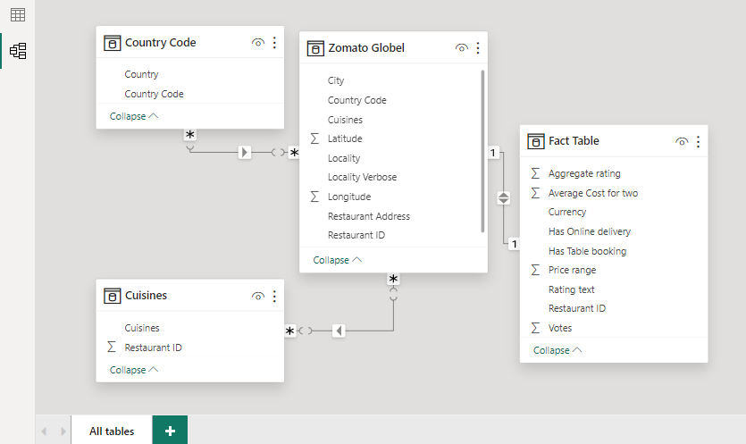

**Table View Manuipulation and Measure Creation**

In the table view of Power BI, we'll perform several functions and manipulations to enhance the data representation:

**Creating "Rating Color" Column in Fact Table:**

Click on the "Fact Table" and create a new column named "Rating Color."

Use the following formula to determine the rating color based on the aggregate rating:

Rating color = IF('Fact Table'[Aggregate rating] = 0, "Not Rated",

IF('Fact Table'[Aggregate rating] <= 2.9, "RED",

IF('Fact Table'[Aggregate rating] <= 3.4, "Orange",

IF('Fact Table'[Aggregate rating] < 4.4, "GREEN",

IF('Fact Table'[Aggregate rating] <= 5, "Dark green", "Others")))))

Press Enter to create the new column for the rating color.

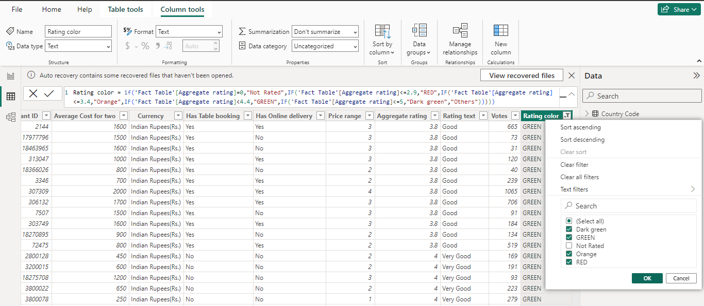

**Creating "Continent" Column in Country Code Table:**

Click on the "Country Code" table and create a new column named "Continent."

Use the SWITCH function to assign continent names based on the country code:

Continent = SWITCH('Country Code'[Country Code],189, "Africa",215, "Europe",37, "NAM",216, "SAM",14, "Oceania",148, "Oceania","Asia")

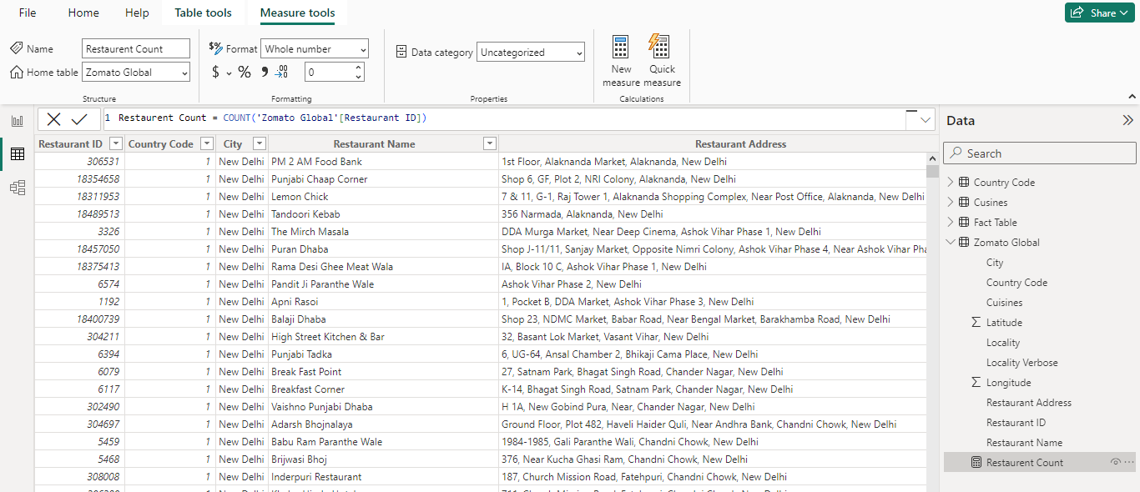

Press Enter to create the new column for the continent.

**Creating Measures:**

Right-click on the "Zomato Global" table and select "New Measure."

Name the measure "Restaurant Count" and use the formula:

Restaurant Count = COUNT('Zomato Global'[Restaurant ID])

Press Enter to create the measure.

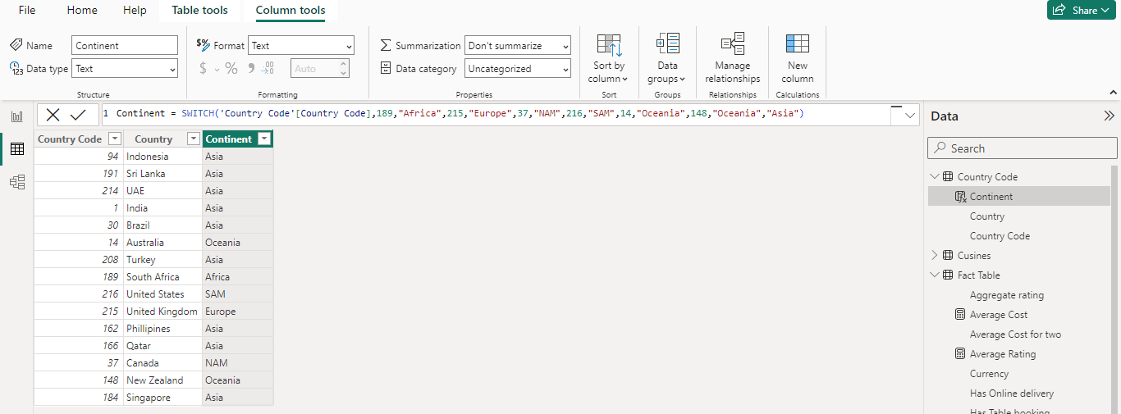

Similarly, create the following measures for the "**Fact Table**":

"Average Cost" using the formula:

Average Cost = AVERAGE('Fact Table'[Average Cost for two])

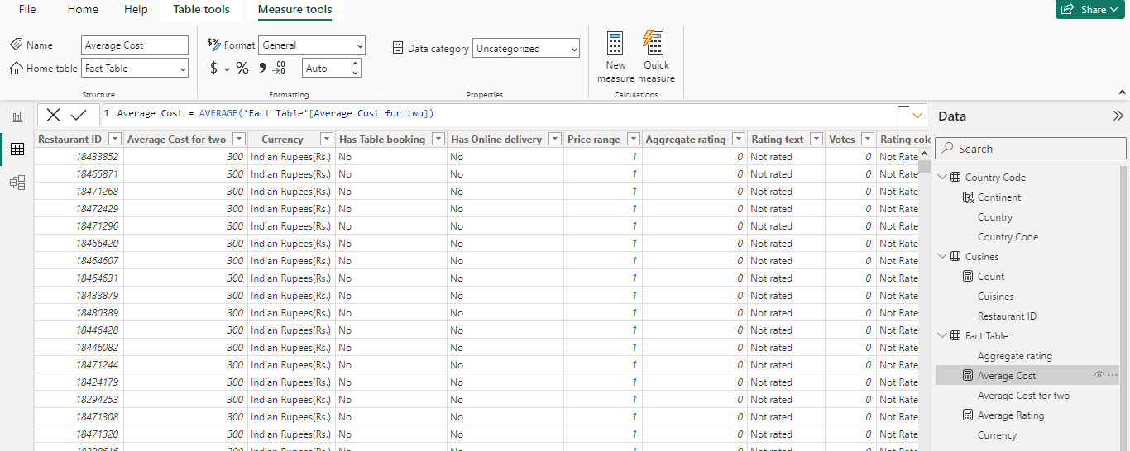

"Average Rating" using the formula:

Average Rating = AVERAGE('Fact Table'[Aggregate rating])

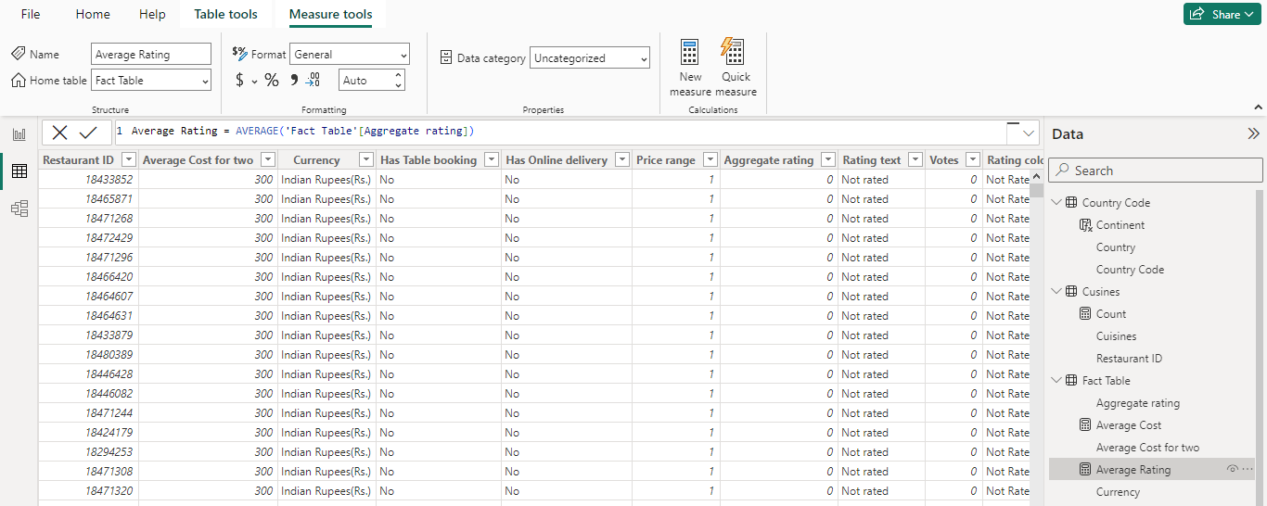

Also, create a measure for the "**Cuisines**" table named "Count" with the formula:

Count = DISTINCTCOUNT(Cuisines[Cuisines])

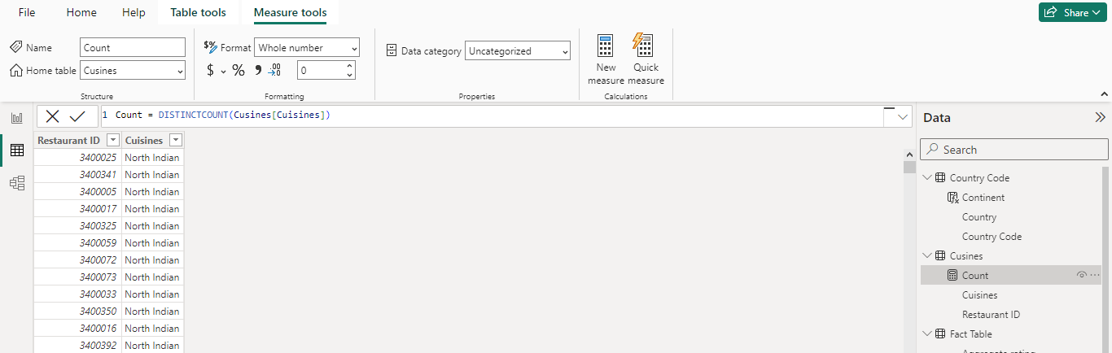

Press Enter after entering each formula to create the respective measures.

**4.2 RESULT / DASHBOARD**

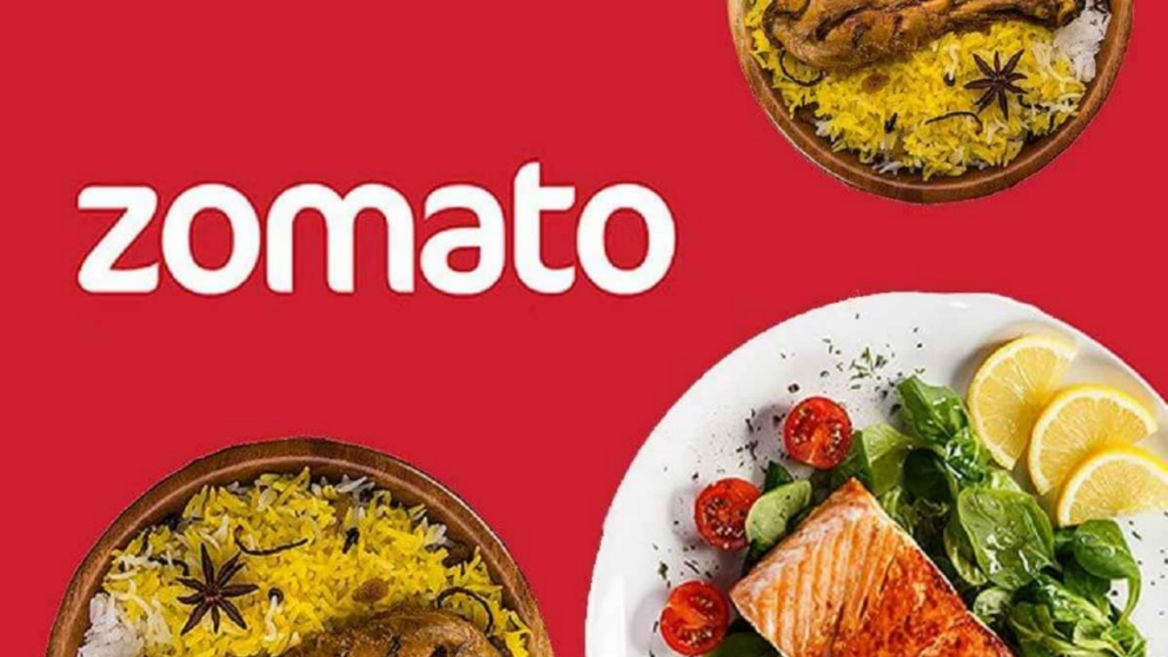

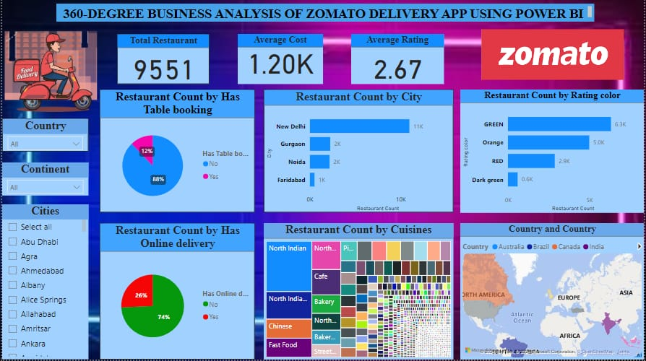

**CONCLUSION**

In conclusion, the development of a tailored Power BI dashboard for analyzing Zomato's delivery app data represents a significant step towards enhancing the company's operational efficiency and competitiveness in the online food delivery market. By integrating multiple data sources and incorporating interactive features, the dashboard provides stakeholders with a comprehensive view of business operations and enables dynamic exploration of key metrics and trends. Moreover, the inclusion of predictive and prescriptive analytics capabilities empowers decision-makers with insights to anticipate future trends and optimize operational processes and marketing strategies. Ultimately, the project's goal is to equip Zomato with the tools necessary to drive strategic decision-making, foster growth, and meet the evolving needs of customers and partners in the digital age.

**FUTURE SCOPE**

The future scope of Power BI is imbued with boundless potential, poised to revolutionize the landscape of data-driven decision-making. As analytics and machine learning continue to evolve, Power BI stands at the forefront of innovation, offering unparalleled opportunities for organizations to harness data for strategic insights and competitive advantage. One of the most promising avenues lies in the integration of predictive analytics capabilities, enabling organizations to anticipate future trends and customer behaviors with unprecedented accuracy. By analyzing historical data patterns, Power BI could empower businesses to proactively address customer needs, driving heightened satisfaction and loyalty.

Moreover, Power BI's seamless integration with diverse data sources paves the way for a more comprehensive understanding of business operations. By incorporating data from a myriad of sources including IoT devices, social media platforms, and cloud databases, organizations can gain deeper insights into their operations and customer interactions. However, in light of escalating data privacy and security concerns, future iterations of Power BI projects must prioritize the implementation of robust data governance frameworks. Ensuring stringent data protection measures will be essential to secure the handling of sensitive information and maintain compliance with regulatory requirements.

Looking ahead, the integration of real-time data streams holds immense promise for Power BI projects. By leveraging real-time data feeds, organizations can access up-to-the-minute insights, enabling agile decision-making and rapid response to evolving market dynamics. This real-time capability has the potential to fundamentally transform the way businesses interact with their data, fostering a culture of agility and adaptability in an increasingly dynamic business environment.

In conclusion, the future trajectory of Power BI is characterized by its capacity to drive innovation, agility, and actionable insights. By harnessing the platform's advanced analytics, seamless data integration, and real-time capabilities, organizations can unlock new horizons for growth, efficiency, and sustained competitive advantage in the digital era.

**REFERENCES**

<https://learn.techsaksham.org/>

<https://portal.naanmudhalvan.tn.gov.in/>

**LINKS**

<https://github.com/santhiya2k4/power-bi>